CS21120 Word Ladder Assignment Document

**Module Code:**

**CS21120 Program Design, Data Structures and Algorithms**

**Author:**

**Chris Savill –** [**chs17@aber.ac.uk**](mailto:chs17@aber.ac.uk)

Table of Contents

Use Case 4

Class Diagram 5

Design 6

Graph Class 6

Vertex Class 6

WordReader 6

Menu 6

WordLadderDriver 6

Justification of Algorithms 7

Generation Algorithm 7

Discovery Algorithm 7

Pseudo-code 8

Initial start-up 8

Depth-Limited Search (DLS) Algorithm for Generation: 8

Breadth-First Search (BFS) Algorithm for Discovery: 9

Testing 10

Menu Testing 10

Launch Screen: 10

Selecting Option 1 – Generation 10

Selecting Option 2 – Discovery 11

Selecting Option 3 – Exit 11

Selecting an invalid option 11

Generation Testing 12

‘test’ with ‘5’ 12

‘bed’ with ‘462’ (limit at 461) 13

‘worker’ with ‘50’ 14

Discover Testing 14

‘head’ with ‘foot’ 15

‘print’ with ‘light’ 15

‘shine’ with ‘rhyme’ 16

More Tests: 16

Java Source Code 18

Graph 18

Vertex 28

WordReader 31

Menu 34

WordLadderDriver 35

# Use Case

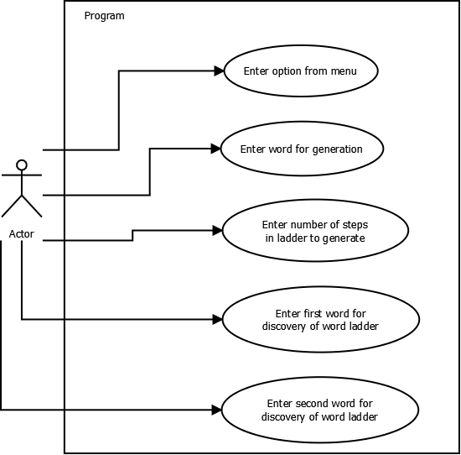

The purpose of the above use case diagram is to illustrate the interactions that the user will have with the program. The user will be able to enter in their option at the launch menu, enter a word to generate a ladder for, enter the depth of the ladder they want to try and generate and enter in a start and end word for the discovery of a word ladder.

# Class Diagram

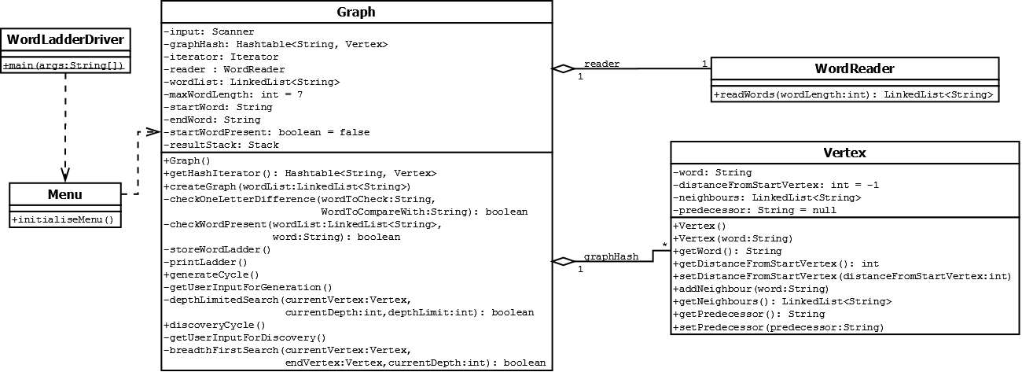

The class diagram above shows how the classes are structured and how they are linked to each other. The program was designed to enforce low-coupling and high-cohesion. By having the Graph class encapsulate all of the methods related to graph generation, traversal of the graph using search algorithms enforces high-cohesion. By having only two other classes (Vertex and WordReader) linked to the Graph class, low coupling is enforced as well. The reason the other two classes are separate is because the WordReader class contains the method relating to file input so there was no need to encapsulate it within the Graph class where it was not relevant. The Vertex class is kept separate because it has its own properties and methods related to vertices so it makes sense to encapsulate those together in the Vertex class.

# Design

Below are the class descriptions, refer to class diagram above where necessary. Justifications of design are given for each class where appropriate.

## Graph Class

To accomplish the task at hand guidance was given that a graph data structure consisting of a hash table and vertices would be the best method. The hash table data structure would be implemented using the Hashtable.java class. It would use the words of type String as keys and vertices would be the data that the keys were hashed to.

As the class diagram indicates, the Graph class contains methods relating to setting up and creating the graph as well as methods to run the search algorithms for the two mains functions of the program.

## Vertex Class

The vertex class was designed to act as nodes/vertices of the graph class. The class contains four variables:

1. ‘word’ which is a string to store the word to which the vertex refers to;
2. ‘distanceFromStartVertex’ which is an int to label how far from the start word the vertex lies (initialised to -1 to mark as unexplored);
3. ‘neighbours’ which is a linked list of strings to store all of the words that have only a one letter difference;
4. ‘predecessor’ which is a string to store the word of the vertex that the vertex was expanded from (initialised to null as there is no predecessor when generated).

Having the linked list of neighbours essentially creates a network of words which represents a graph data structure, along with the hash table to access the graph’s vertices.

## WordReader

The WordReader class as shown by the class diagram is used by the Graph class for reading in the word lists from the data files provided. The list created is then used to add to the hash table and create new vertices from each word in the word list to create the graph.

## Menu

This class is just a simple menu class that gives the user three options, generation, discovery and exit.

## WordLadderDriver

As indicated by the class diagram this class just contains the main method, it is the first class launched on start-up and just creates an instance of the Menu class and calls the initialiseMenu method.

# Justification of Algorithms

## Generation Algorithm

For the generation part of the program it seemed apparent that a Depth-Limited Search (DLS) would be the most appropriate algorithm to use. This is because the user would enter in the number of steps in the ladder which is basically the depth at which to go down. As a Depth-Limited Search algorithm acts like a Depth-First Search (DFS) but with a limit on the depth, it made sense just to use a Depth-Limited Search instead of a Depth-First Search. As soon as the depth limit was reached the resulting ladder would have been generated successfully. It must be referenced that the book ‘Artificial Intelligence: A Modern Approach’ Third Edition aided me in the decision and implementation of the Depth-Limited Search algorithm for the generation part of the program.

Reference- Russel, S, Norvig, P (2010). *Artificial Intelligence: A Modern Approach*. 3rd ed. New Jersey: PEARSON. 85-88.

## Discovery Algorithm

For the discovery part of the program it was hinted that Dijkstra’s Algorithm would be one of the best ways to go (at least for an uninformed search). However as Dijkstra’s Algorithm relies on having a weighted graph (of which the graph implemented here is not), there is no point in using it. Without the priority queue due to a weighted graph the algorithm would act exactly like a Breadth-First Search (BFS), this is why a Breadth-First Search was chosen for the discovery algorithm. The Breadth-First Search algorithm is complete and is guaranteed to find the shortest word ladder/path to a solution as it checks the shallowest vertices/nodes first then the next depth below etc. Breadth-First Search is the most efficient uninformed search algorithm to use. There may be a better and more optimal/efficient informed heuristic search algorithm but due to time constraints it was a good idea to get a simpler algorithm working first. It must be referenced that the book ‘Artificial Intelligence: A Modern Approach’ Third Edition aided me in the decision and implementation of the Breadth-First Search algorithm for the discovery part of the program.

Reference - Russel, S, Norvig, P (2010). *Artificial Intelligence: A Modern Approach*. 3rd ed. New Jersey: PEARSON. 81-83.

# Pseudo-code

## Initial start-up

Involves:

* Displaying the menu to the user;
* Getting their option input:
* Checking if their selected option is valid
  + If not get input again and recheck.
  + If yes run the corresponding code.

**Display** "Welcome to the Word Ladder Generator"

**While** (selected option is not equal to the exit option) {

**Prompt** a menu to run either the generation function, discovery function or exit function.

**Read** user's input for option.

**Switch** (selected option) {

**Case 1** (Generation function):

**Run** generation function

**Break** out of switch case

**Case 2** (Discovery function):

**Run** discovery function

**Break** out of switch-case

**Case 3** (Exit):

**Display** "Exiting program"

**Break** out of switch-case

**Default:**

**Display** "Invalid option selected, please select a valid option"

**Break** out of switch case

}

}

## Depth-Limited Search (DLS) Algorithm for Generation:

Recursive DLS-

* Set current word being looked at as the word passed in (start word if at beginning);
* Set distance of current word to current depth (0 for start word);
* Check if current word’s distance from start word is higher than the current depth;
  + If yes, return false.
* If no, check if current word is at the depth limit;
  + If yes, return true.
* If no, for each neighbour word unexplored, if any (distance less than 0):
  + Set predecessor of neighbour word to the current word;
  + Check if a call to the recursive DLS method returns true to a result being found (passing in the neighbour word, the current depth + 1 and the depth limit);
  + If result found equals true, return true.
* If no result found through any path to the depth required, return false (failure).

## Breadth-First Search (BFS) Algorithm for Discovery:

Breadth-First Search-

* Create new frontier queue;
* Set distance from start word to current depth (0 if at beginning/start word);
* Add word to frontier queue;
* While frontier queue is not empty:
  + If current word matches end word, return true.
  + Else set current word to word at the front of the frontier queue and remove front of the queue;
  + For every neighbour of current word unexplored, if any (distance less than 0):
    - Add neighbour to back of frontier queue;
    - Set distance from start word of neighbour to the current depth + 1;
    - Set the predecessor of the neighbour to the current word;

# Testing

The testing approach adopted involved JUnit testing where possible (mainly the Vertex class) and then testing of the actual algorithms through running the program and taking screenshots of the outputs. If there were more time, more extensive JUnit tests would have been created to ensure the program is robust.

## Menu Testing

Here is a simple screenshot walk through of selecting the three options available to the user as well as what happens if the user enters invalid options:

### Launch Screen:

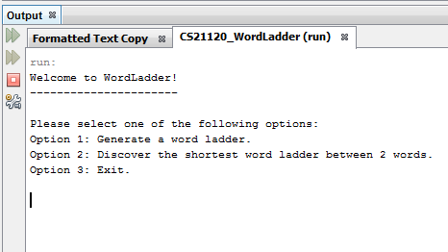

### Selecting Option 1 – Generation

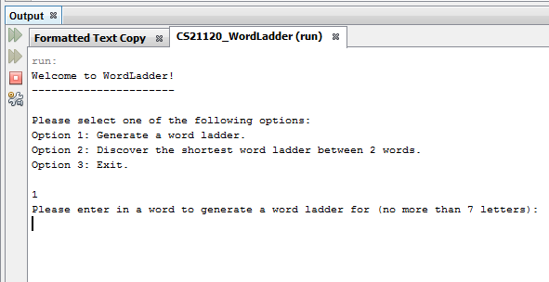

### Selecting Option 2 – Discovery

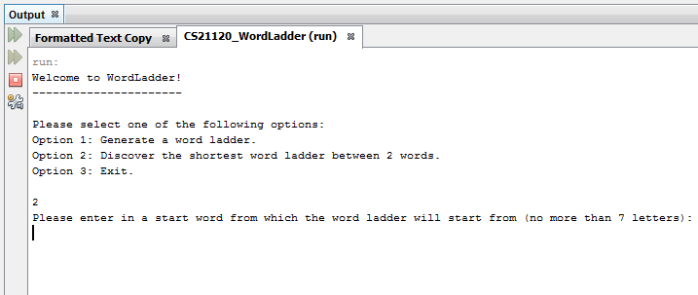

### Selecting Option 3 – Exit

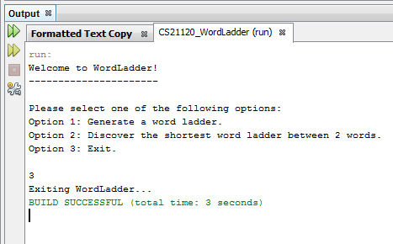

### Selecting an invalid option

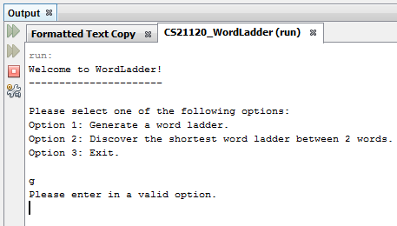

## Generation Testing

Here are three tests on the generation functionality with three different sets of input:

### ‘test’ with ‘5’

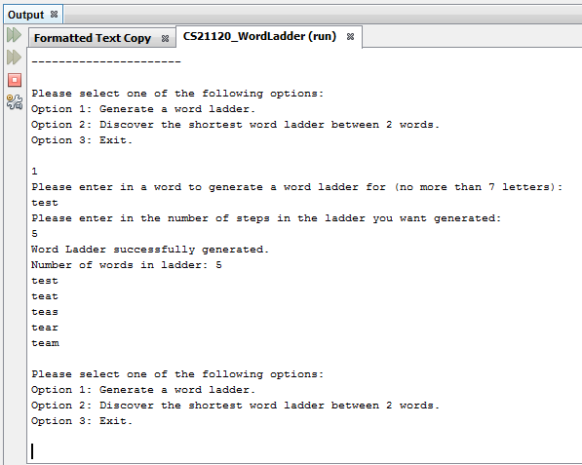

### ‘bed’ with ‘462’ (limit at 461)

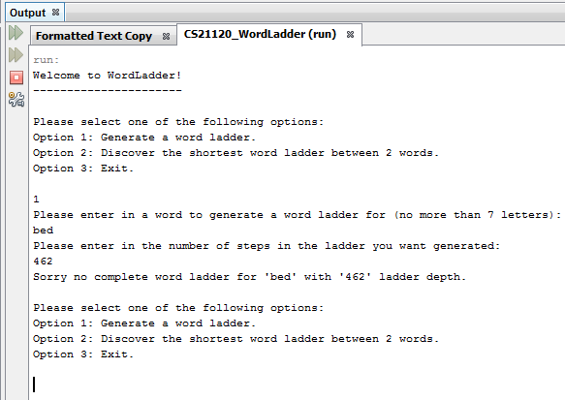

### ‘worker’ with ‘50’

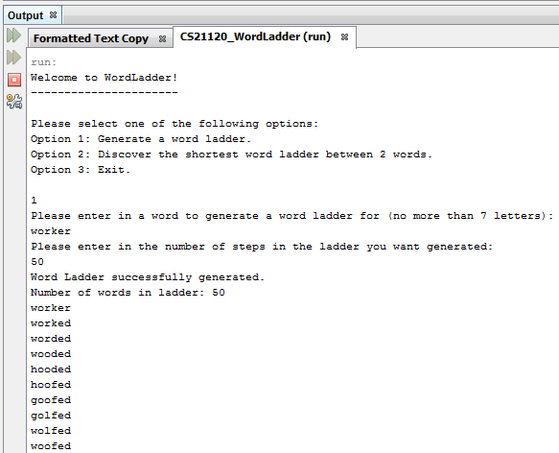

… down to ‘beaten’.

## Discover Testing

Here are three tests on the discovery functionality with three different sets of input:

### ‘head’ with ‘foot’

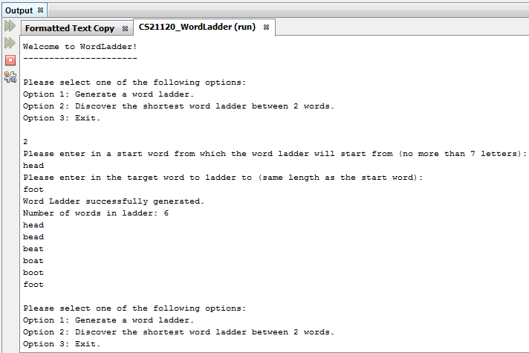

### ‘print’ with ‘light’

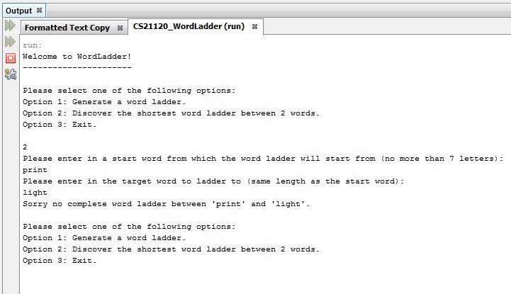

### ‘shine’ with ‘rhyme’

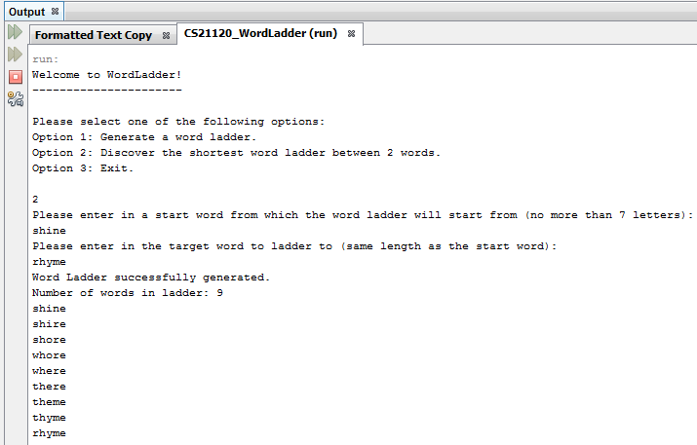

## More Tests

|  |  |  |  |  |
| --- | --- | --- | --- | --- |
| Test Number | Function | Input 1 | Input 2 | Result |
| 1 | Generation | test | 2 | test  teat |
| 2 | Generation | fight | 10 | fight  eight  bight  bigot  begot  beget  begat  began  begin  begun |
| 3 | Generation | sincere | 5 | Sorry no complete word ladder for 'sincere' with '5' ladder depth. |
| 4 | Generation | flights | 3 | flights  alights  blights |
| 5 | Generation | on | 4 | on  an  ah  ad |
| 6 | Discovery | dog | bed | dog  bog  beg  bed |
| 7 | Discovery | crate | night | Sorry no complete word ladder between 'crate' and 'night'. |
| 8 | Discovery | soft | wrap | soft  soot  coot  coop  crop  crap  wrap |
| 9 | Discovery | justice | freight | Sorry no complete word ladder between 'justice' and 'freight'. |
| 10 | Discovery | jumper | joiner | jumper  jumped  dumped  damped  camped  carped  carded  corded  corned  coined  joined  joiner |

# Java Source Code

## Graph

package aber.dcs.cs21120.chs17.WordLadder.dataStructures;  
  
import java.util.Hashtable;  
import java.util.Iterator;  
import java.util.LinkedList;  
import java.util.Map;  
import java.util.Scanner;  
import java.util.Stack;  
  
/** * **CS21120 WordLadder class that contains methods to create a graph and traverse** * **the graph to find word ladders**  
 *  
 * **@author** Chris Savill - chs17  
 */  
public class **Graph** {  
 //////////////////////// Variables ///////////////////////////  
  
 /**  
 * Scanner class used for retrieving user input  
 */  
 private Scanner input = new Scanner(System.*in*);  
 /**  
 * Hash table class used to store the unique words in the key and vertexes  
 * as the data  
 */  
 private Hashtable<String, Vertex> graphHash;  
 /**  
 * Iterator class used to iterate through the hash table  
 */  
 private Iterator<Map.*Entry*<String, Vertex>> iterator;  
 /**  
 * WordReader class used for reading in words from a data file  
 */  
 private WordReader reader;  
 /**  
 * LinkedList of type String used to store all the words read in by the  
 * WordReader class  
 */  
 private LinkedList<String> wordList;  
 /**  
 * int primitive used to set a max word length on words being used in the  
 * word ladder, can be changed later if additional word data files generated  
 * for other lengths  
 */  
 private int maxWordLength = 7;  
 /**  
 * String class used to store the startWord  
 */  
 private String startWord;  
 /**  
 * String class used to store the endWord  
 */  
 private String endWord;  
 /**  
 * boolean primitive used to determine whether or not the start word is  
 * present in the data file being scanned  
 */  
 private boolean startWordPresent = false;  
 /**  
 * Stack class used for storing the resulting words in the word ladder  
 */  
 private Stack resultStack;  
  
 //////////////////////// Constructors ///////////////////////////  
 /**  
 * Default constructor that just initialises the hash table  
 */  
 public **Graph**() {  
 graphHash = new Hashtable();  
 reader = new WordReader();  
 resultStack = new Stack();  
 }  
  
 //////////////////////// Methods ///////////////////////////  
 /** * **Method that returns the iterator for the hash table**  
 *  
 * **@return** Returns the iterator for the graphHash hash table  
 */  
 public Iterator **getHashIterator**() {  
 iterator = graphHash.entrySet().iterator();  
 return iterator;  
 }  
  
 /** * **Method that builds the graph using the word list passed in**  
 *  
 * **@param** wordList The LinkedList of type String from which a graph is built  
 * from  
 */  
 public void **createGraph**() {  
 String key;  
 Vertex vertex;  
 Vertex newVertex;  
 Iterator<Map.*Entry*<String, Vertex>> iterator;  
  
 for (int counter = 0; counter < wordList.size(); counter++) {  
 graphHash.put(wordList.get(counter), newVertex = new Vertex(wordList.get(counter))); //Creates a new vertex, initialising it with the word in the word list at the index of the counter  
 iterator = getHashIterator(); //Retrieves a new iterator for the hash table within the graph class  
  
 while (iterator.hasNext()) {  
 key = iterator.next().getKey(); //Assigns the next key from to the iterator to the key variable  
 vertex = graphHash.get(key); //Assigns the vertex in the hash table referenced from the key to the vertex variable  
 if (checkOneLetterDifference(newVertex.getWord(), vertex.getWord()) == true) {  
 vertex.addNeighbour(newVertex.getWord()); //Adds newVertex word to the neighbour adjacency list of the current vertex it is being compared to  
 newVertex.addNeighbour(vertex.getWord()); //Adds the current vertex word to the neighbour adjacency list of the newVertex it is being compared to  
 }  
 }  
 }  
 }  
  
 /** * **Method to check if the two words being passed in only have a one letter** * **difference**  
 *  
 * **@param** wordToCheck A String to compare with the wordToCompareWith String  
 * **@param** wordToCompareWith A String to compare with the wordToCheck String  
 * **@return** Returns true or false depending on whether or not the two works  
 * only have a one letter difference  
 */  
 private boolean **checkOneLetterDifference**(String wordToCheck, String wordToCompareWith) {  
 boolean oneLetterDifference = false;  
 int numberOfLettersMatched = 0;  
  
 for (int counter = 0; counter < wordToCheck.length(); counter++) {  
 if (wordToCheck.charAt(counter) == wordToCompareWith.charAt(counter)) {  
 numberOfLettersMatched++;  
 }  
 }  
  
 if (numberOfLettersMatched == wordToCheck.length() - 1) {  
 oneLetterDifference = true;  
 }  
 return oneLetterDifference;  
 }  
  
 /** * **Method that checks if the word passed in is present in the word list** * **supplied**  
 *  
 * **@param** wordList The LinkedList of type String that contains the list of  
 * words for comparison  
 * **@param** word The String to compare with the wordList LinkedList  
 * **@return** Returns true or false depending on whether or not the word passed  
 * in is present in he word list supplied  
 */  
 private boolean **checkWordPresent**(LinkedList<String> wordList, String word) {  
 boolean wordPresent = false;  
 for (int counter = 0; counter < wordList.size() && wordPresent == false; counter++) {  
 if (wordList.get(counter).equals(word)) {  
 wordPresent = true;  
 }  
 }  
 return wordPresent;  
 }  
  
 /**  
 * Method that sets off the word ladder generation cycle, first by calling a  
 * method that gets the word to ladder from the user, then calls a method  
 * that creates a new graph, then calls the search algorithm, evaluates its  
 * result and acts accordingly  
 */  
 public void **generateCycle**() {  
 int ladderDepth = 0;  
 ladderDepth = getUserInputForGeneration();  
 createGraph();  
  
 if (depthLimitedSearch(graphHash.get(startWord), 0, ladderDepth - 1) == true) { //Evaluates the result of the recursiveDepthLimitedSearchForGeneration method  
 storeWordLadder();  
 printLadder();  
 } else {  
 System.*out*.println("Sorry no complete word ladder for '" + startWord + "' with '" + ladderDepth + "' ladder depth.");  
 }  
 }  
  
 /**  
 * Method that cycles through getting the user to input a valid word for the  
 * word ladder generation and checks if it exists in the data files supplied  
 * and then gets the user to input the depth of the ladder they want  
 */  
 private int **getUserInputForGeneration**() {  
 while (startWordPresent == false) {  
 startWord = "WordTooLong"; //"WordTooLong" used as it has more than 7 letters and to initialise word ready for while loop condition checking  
 while (startWord.length() > maxWordLength) {  
 System.*out*.println("Please enter in a word to generate a word ladder for (no more than 7 letters): ");  
 startWord = input.next();  
 }  
  
 wordList = reader.readWords(startWord.length());  
  
 if (checkWordPresent(wordList, startWord) == true) { //Evaluates if the word chosen exists in the appropriate word data file  
 startWordPresent = true;  
 } else {  
 System.*out*.println("Word is not present in file, please try another word.");  
 }  
 }  
 System.*out*.println("Please enter in the number of steps in the ladder you want generated: ");  
  
 while (!input.hasNextInt()) {  
 System.*out*.println("Please enter in a valid option.");  
 input.next();  
 }  
  
 return input.nextInt();  
 }  
  
 /** * **Depth-Limited Search (DLS) algorithm to find the word ladder for a word** * **up to a certain depth**  
 *  
 * **@param** currentVertex The current vertex being evaluated to see if goal  
 * state has been met.  
 * **@param** currentDepth The current depth at which the current vertex lies  
 * at.  
 * **@param** depthLimit The maximum depth that the search will go to; the goal  
 * state  
 * **@return** Returns True or false based on whether the goal state has been  
 * found.  
 */  
 private boolean **depthLimitedSearch**(Vertex currentVertex, int currentDepth, int depthLimit) {  
 boolean resultFound = false;  
 if (currentVertex.getDistanceFromStartVertex() < 0) {  
 currentVertex.setDistanceFromStartVertex(currentDepth);  
 }  
  
 if (currentVertex.getDistanceFromStartVertex() > currentDepth) {  
 return false;  
 } else {  
 if (currentVertex.getDistanceFromStartVertex() == depthLimit) {  
 endWord = currentVertex.getWord();  
 return true;  
 } else {  
 for (String neighbour : graphHash.get(currentVertex.getWord()).getNeighbours()) {  
 if (graphHash.get(neighbour).getDistanceFromStartVertex() < 0) {  
 graphHash.get(neighbour).setPredecessor(currentVertex.getWord()); //Sets the predecessor/parent vertex of the neighbour/child vertex to the current vertex  
 resultFound = depthLimitedSearch(graphHash.get(neighbour), currentDepth + 1, depthLimit);  
 if (resultFound == true) {  
 return true;  
 }  
 }  
 }  
 }  
 }  
 return false;  
 }  
  
 /**  
 * Method that sets off the word ladder discovery cycle, first by calling a  
 * method that gets the words to ladder between from the user, then calls a  
 * method that creates a new graph, then calls the search algorithm,  
 * evaluates its result and acts accordingly  
 */  
 public void **discoveryCycle**() {  
 getUserInputForDiscovery();  
 createGraph();  
  
 if (breadthFirstSearch(graphHash.get(startWord), graphHash.get(endWord), 0) == true) { //Evaluates the result of the iterativeDeepeningSearchForDiscovery method  
 storeWordLadder();  
 printLadder();  
 } else {  
 System.*out*.println("Sorry no complete word ladder between '" + startWord + "' and '" + endWord + "'.");  
 }  
 }  
  
 /**  
 * Method that cycles through getting the user to input two valid words for  
 * the word ladder discovery and checks if they exist in the data files  
 * supplied  
 */  
 private void **getUserInputForDiscovery**() {  
 boolean endWordPresent = false;  
  
 while (startWordPresent == false) {  
 startWord = "WordTooLong"; //"WordTooLong" used as it has more than 7 letters and to initialise word ready for while loop condition checking  
 endWord = "WordTooLong";  
 while (startWord.length() > maxWordLength) {  
 System.*out*.println("Please enter in a start word from which the word ladder will start from (no more than 7 letters): ");  
 startWord = input.next();  
 }  
  
 wordList = reader.readWords(startWord.length());  
  
 if (checkWordPresent(wordList, startWord) == true) { //Evaluates if the word chosen exists in the appropriate word data file  
 startWordPresent = true;  
 } else {  
 System.*out*.println("Start word is not present in file, please try another word.");  
 }  
 }  
  
 while (endWordPresent == false) {  
 while (endWord.length() != startWord.length()) {  
 System.*out*.println("Please enter in the target word to ladder to (same length as the start word): ");  
 endWord = input.next();  
 }  
  
 if (checkWordPresent(wordList, endWord) == true) { //Evaluates if the word chosen exists in the appropriate word data file  
 endWordPresent = true;  
 } else {  
 endWord = "WordTooLong";  
 System.*out*.println("Target word is not present in file, please try another word.");  
 }  
 }  
 }  
  
 /** * **Breadth-First Search (BFS) algorithm to find the shortest word ladder** * **between two words**  
 *  
 * **@param** currentVertex The current vertex/word being analysed  
 * **@param** endVertex The target vertex/word/goal state  
 * **@param** currentDepth The current depth in the graph  
 * **@return** Returns true if word ladder has been found, false if not  
 */  
 private boolean **breadthFirstSearch**(Vertex currentVertex, Vertex endVertex, int currentDepth) {  
 LinkedList<String> frontierQueue = new LinkedList<String>();  
 currentVertex.setDistanceFromStartVertex(currentDepth); //Sets distance from start vertex to the current depth, if it is the start vertex, distance would be 0  
 frontierQueue.add(currentVertex.getWord()); //Adds the current vertex to the queue  
  
 while (!frontierQueue.isEmpty()) { //Evaluates if the frontierQueue queue is not empty  
 if (currentVertex.getWord().equals(endVertex.getWord())) { //Checks if goal state has been met  
 endWord = currentVertex.getWord();  
 return true;  
 } else {  
 currentVertex = graphHash.get(frontierQueue.peek().toString()); //Sets the current vertex to the vertex at the front of the queue  
 frontierQueue.remove(); //Removes the current vertex from the frontierQueue queue, (counted as explored)  
  
 for (String neighbour : graphHash.get(currentVertex.getWord()).getNeighbours()) {  
 if (graphHash.get(neighbour).getDistanceFromStartVertex() < 0) { //Evaluates if the vertexes have been explored  
 frontierQueue.add(graphHash.get(neighbour).getWord()); //Adds neighbour/child vertex to end of queue  
 graphHash.get(neighbour).setDistanceFromStartVertex(currentDepth + 1); //Sets the distance from start vertex to the next depth level  
 graphHash.get(neighbour).setPredecessor(currentVertex.getWord()); //Sets the predecessor/parent vertex of the neighbour/child vertex to the current vertex  
 }  
 }  
 }  
 }  
 return false; //Return false if no result found. If false is returned at the top, a failure to find the result has occurred  
 }  
  
 /** * **Method that stacks the path/word ladder between the two words, works** * **backwards from the goal state using the predecessor variable**  
 *  
 * **@param** endWord The target vertex/word/goal state  
 */  
 private void **storeWordLadder**() {  
 String currentWord = endWord;  
 resultStack.push(endWord); //Adds the goal state word to the result stack  
  
 while (graphHash.get(currentWord).getPredecessor() != null) { //Loops until hit start vertex as the start vertex would have no predecessor so would be null  
 resultStack.push(graphHash.get(currentWord).getPredecessor()); //Adds predecessor to result stack  
 currentWord = graphHash.get(currentWord).getPredecessor(); //Sets the current word to the predecessor vertex  
 }  
 }  
  
 /**  
 * Method to print the resulting ladder from the result stack  
 */  
 private void **printLadder**() {  
 System.*out*.println("Word Ladder successfully generated.");  
 System.*out*.println("Number of words in ladder: " + resultStack.size());  
 while (!resultStack.isEmpty()) {  
 System.*out*.println(resultStack.pop().toString()); //Prints out the word ladder stack if successful  
 }  
 }  
}

## Vertex

package aber.dcs.cs21120.chs17.WordLadder.dataStructures;  
  
import java.util.LinkedList;  
  
/** * **CS21120 WordLadder class to represent a vertex/node for use within the graph**  
 *  
 * **@author** Chris Savill - chs17  
 */  
public class **Vertex** {  
 //////////////////////// Variables ///////////////////////////  
  
 /**  
 * String class used to store the word within the vertex  
 */  
 private String word;  
 /**  
 * int primitive used to store the distance of the vertex from the start  
 * vertex, defaults to -1 to represent that the vertex is unexplored  
 */  
 private int distanceFromStartVertex = -1;  
 /**  
 * LinkedList of type String used as an adjacency list for the vertex of all  
 * the neighbours  
 */  
 private LinkedList<String> neighbours;  
 /** * **String class used to store the predecessor of the vertex.** Defaults to  
 * null as no predecessor is assigned at first.  
 */  
 private String predecessor = null;  
  
 //////////////////////// Constructors ///////////////////////////  
 /**  
 * Default constructor  
 */  
 public **Vertex**() {  
 }  
  
 /** * **Constructor used for initialising the word and neighbours**  
 *  
 * **@param** word the String to initialise the vertex word variable  
 */  
 public **Vertex**(String word) {  
 this.word = word;  
 neighbours = new LinkedList();  
 }  
  
 //////////////////////// Methods ///////////////////////////  
 /** * **Method to return the word assigned to the vertex**  
 *  
 * **@return** Returns word  
 */  
 public String **getWord**() {  
 return this.word;  
 }  
  
 /** * **Method to return the distance that this vertex is from the start vertex**  
 *  
 * **@return** Returns distanceFromStartVertex  
 */  
 public int **getDistanceFromStartVertex**() {  
 return this.distanceFromStartVertex;  
 }  
  
 /** * **Method to set the value of the distance that this vertex it from the** * **start vertex**  
 *  
 * **@param** distanceFromStartVertex The int value to initialise the vertex  
 * distanceFromStartVertex variable  
 */  
 public void **setDistanceFromStartVertex**(int distanceFromStartVertex) {  
 this.distanceFromStartVertex = distanceFromStartVertex;  
 }  
  
 /** * **Method to add a new neighbour to the adjacency list (LinkedList) of** * **neighbours**  
 *  
 * **@param** word The string to add to the adjacency list of the vertex  
 */  
 public void **addNeighbour**(String word) {  
 neighbours.add(word);  
 }  
  
 /** * **Method to return the LinkedList of neighbours**  
 *  
 * **@return** Returns neighbours  
 */  
 public LinkedList<String> **getNeighbours**() {  
 return this.neighbours;  
 }  
  
 /** * **Method to return the predecessor of the vertex**  
 *  
 * **@return** Returns predecessor  
 */  
 public String **getPredecessor**() {  
 return this.predecessor;  
 }  
  
 /** * **Method to set the predecessor of the vertex**  
 *  
 * **@param** predecessor The String to initialise the vertex predecessor  
 * variable  
 */  
 public void **setPredecessor**(String predecessor) {  
 this.predecessor = predecessor;  
 }  
}

## WordReader

package aber.dcs.cs21120.chs17.WordLadder.dataStructures;  
  
import java.io.BufferedReader;  
import java.io.FileReader;  
import java.io.IOException;  
import java.util.LinkedList;  
import java.util.logging.Level;  
import java.util.logging.Logger;  
  
/** * **Class that contains various methods to read words from a file**  
 *  
 * **@author** Chris Savill - chs17  
 */  
public class **WordReader** {  
  
 //////////////////////// Methods ///////////////////////////  
 /** * **Method that reads the words of a file into a LinkedList of String type**  
 *  
 * **@param** wordLength int value of the word length for use with defining the  
 * data file to be used  
 * **@return** Returns the new LinkedList of String type containing the word  
 * list  
 */  
 public LinkedList<String> **readWords**(int wordLength) {  
 int numberOfWords = 0;  
 int numberOfRelevantWords = 0;  
 String wordRead;  
 boolean wordAlreadyStored;  
  
 try {  
 BufferedReader fileToBeRead = new BufferedReader(new FileReader("WordsOfLength" + wordLength + ".dat"));  
  
 while (fileToBeRead.readLine() != null) { //Loops to the end of the file  
 numberOfWords++;  
 }  
  
 fileToBeRead.close();  
  
 } catch (IOException ex) {  
 Logger.*getLogger*(WordReader.class.getName()).log(Level.*SEVERE*, null, ex);  
 System.*out*.println("File could not be accessed.");  
 }  
  
 try {  
 BufferedReader fileToBeRead = new BufferedReader(new FileReader("WordsOfLength" + wordLength + ".dat"));  
 LinkedList<String> wordStore = new LinkedList<String>();  
  
 for (int counter = 0; counter < numberOfWords; counter++) {  
 if (numberOfRelevantWords == 0) {  
 try {  
 wordRead = fileToBeRead.readLine();  
 if (wordRead.length() == wordLength) {  
 wordStore.add(wordRead); //Adds new word to the word store LinkedList  
 }  
 } catch (IOException ex) {  
 Logger.*getLogger*(WordReader.class.getName()).log(Level.*SEVERE*, null, ex);  
 }  
 } else {  
 wordAlreadyStored = false;  
 try {  
 wordRead = fileToBeRead.readLine();  
 if (wordRead.length() == wordLength){  
 for (int counter2 = 0; counter2 < numberOfRelevantWords || wordAlreadyStored == true; counter2++) {  
   
 if (wordStore.get(counter2).equals(wordRead)) { //Evaluates if word is already contained in the word store LinkedList  
 wordAlreadyStored = true;  
 }  
 }  
 if (wordAlreadyStored == false) {  
 wordStore.add(wordRead);  
 numberOfRelevantWords++;  
 }  
 }   
 } catch (IOException ex) {  
 Logger.*getLogger*(WordReader.class.getName()).log(Level.*SEVERE*, null, ex);  
 }  
 }  
 }  
 try {  
 fileToBeRead.close();  
 return wordStore;  
 } catch (IOException ex) {  
 Logger.*getLogger*(WordReader.class.getName()).log(Level.*SEVERE*, null, ex);  
 }  
 } catch (IOException ex) {  
 Logger.*getLogger*(WordReader.class.getName()).log(Level.*SEVERE*, null, ex);  
 }  
 return null;  
 }  
}

## Menu

package aber.dcs.cs21120.chs17.WordLadder.wordLadderFunctions;  
  
import aber.dcs.cs21120.chs17.WordLadder.dataStructures.Graph;  
import java.util.Scanner;  
  
/** * **CS21120 WordLadder menu launcher class**  
 *  
 * **@author** Chris Savill - chs17  
 */  
public class **Menu** {  
 //////////////////////// Methods ///////////////////////////  
  
 /**  
 * Method to launch a menu  
 */  
 public void **initialiseMenu**() {  
 Graph graph;  
 int menuChoice = 0;  
 Scanner input = new Scanner(System.*in*);  
  
 System.*out*.println(  
 "Welcome to WordLadder!");  
 System.*out*.println(  
 "----------------------");  
  
 do {  
 System.*out*.println("**\n**Please select one of the following options: ");  
 System.*out*.println("Option 1: Generate a word ladder.");  
 System.*out*.println("Option 2: Discover the shortest word ladder between 2 words.");  
 System.*out*.println("Option 3: Exit.**\n**");  
  
 while (!input.hasNextInt()) {  
 System.*out*.println("Please enter in a valid option.");  
 input.next();  
 }  
  
 menuChoice = input.nextInt();  
  
 switch (menuChoice) {  
 case 1:  
 graph = new Graph();  
 graph.generateCycle();  
 break;  
 case 2:  
 graph = new Graph();  
 graph.discoveryCycle();  
 break;  
 case 3:  
 System.*out*.println("Exiting WordLadder...");  
 break;  
 default:  
 System.*out*.println("Invalid option selected, please select a valid option.");  
 }  
 } while (menuChoice  
 != 3);  
 }  
}

## WordLadderDriver

package aber.dcs.cs21120.chs17.WordLadder.wordLadderFunctions;  
  
/** * **CS21120 WordLadder project main class**  
 *  
 * **@author** Chris Savill - chs17  
 */  
public class **WordLadderDriver** {  
  
 /** * **Main method**  
 *  
 * **@param** args the command line arguments  
 */  
 public static void ***main***(String[] args) {  
 Menu mainMenu = new Menu();  
 mainMenu.initialiseMenu();  
 }  
}